**Submitted by: Basavraj Jaliminche (8800149)**

**Assignment - 2**

**Problem Description:**

A school has 100 lockers and 100 students. All lockers are closed on the first day of school. As the students enter, the first student, denoted S1, opens every locker. Then the second student, S2, begins with the second locker, denoted L2, and closes every other locker. Student S3 begins with the third locker and changes every third locker (closes it if it was open, and opens it if it was closed). Student S4 begins with locker L4 and changes every fourth locker. Student S5 starts with L5 and changes every fifth locker, and so on, until student S100 changes L100.After all the students have passed through the building and changed the lockers, which lockers are open? Write a program to find your answer. The program should display the answer like this:  
Locker x is open  
Locker y is open  
...  
Locker z is open  
(Hint: Use an array of 100 Boolean elements, each of which indicates whether a locker is open   
(true) or closed (false). Initially, all lockers are closed.)

**Solution:**

**Analysis:**

* We have a problem of student locker puzzle.
* Initially all lockers are closed.
* We have 100 lockers and 100 students.
* Student-S1 begins with locker L1. opens all lockers.
* Student-S2 begins with locker L2. closes every other locker.
* Student-S3 begins with locker L3. Changes states of every 3rd locker.
* Student-S4 begins with locker L4. Changes states of every 3rd locker.
* Student-S5 begins with locker L4. Changes states of every 3rd locker.
* So we go upto Student S100- begins with locker L100. Changes states of every 3rd locker.
* So for every student no he or she will open or close locker based on the state.
* So output should be which lockers are open.
* To do so we have to use Boolean array of 100 elements.
* We want answer in format of “Locket x is open”

**Design:**

**Steps**

1. Creating array of 100 Boolean elements.
2. Initially all lockers are closed. Lockers are false.
3. Student 1 open lockers. All lockers should be true.
4. create variables for locker and student.
5. One buy one student comes and open lockers with their same number and adjacent count .for this we have to use nested for loop.
6. In nested for loop we have to use if else condition to change the state of locker open to close and close to open.
7. Printing the results in the given format.

**Coding:**

Code : /*

* @author Basavraj Jaliminche (8800149)

* PROG8580 - Computer Programming - Section 1

* Assignment 2

*/

**package** Assignment;

**public** **class** locker {

**public** **static** **void** main(String[] args) {

/* creating array of 100 boolean elements */

**boolean**[] lockers = **new** **boolean**[100];

/* Initially all lockers are closed */

**for** (**int** i = 0; i < 100; i++) {

lockers[i] = **false**;

}

/* Initially, S1 opens all lockers */

**for** (**int** i = 0; i < 100; i++) {

lockers[i] = **true**;

}

/* Creating variables for student and locker */

**int** j;

**int** l;

/* students change the locker state */

**for** (j = 2; j <= 100; j++) {

/* for every locker, notice we start from L1 */

**for** (l = j - 1; l < 100; l = l + j) {

/*

* Condition for change the state of lockers (open if closed, close if opened)

*/

**if** (lockers[l]) {

lockers[l] = **false**;

}

**else** {

lockers[l] = **true**;

}

}

}

/* printing results of all lockers which are open */

**for** (**int** i = 0; i < 100; i++) {

**if** (lockers[i] == **true**) {

System.***out***.printf("Locker %d is open\n", i + 1);

}

}

}

}

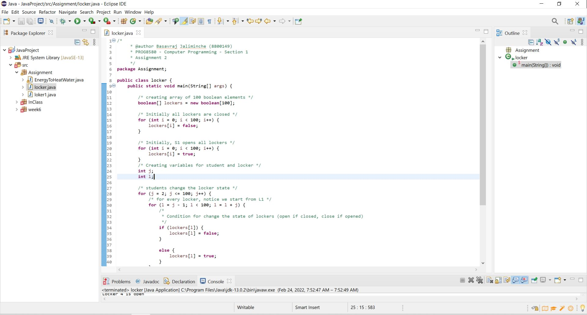

**Code part 1**

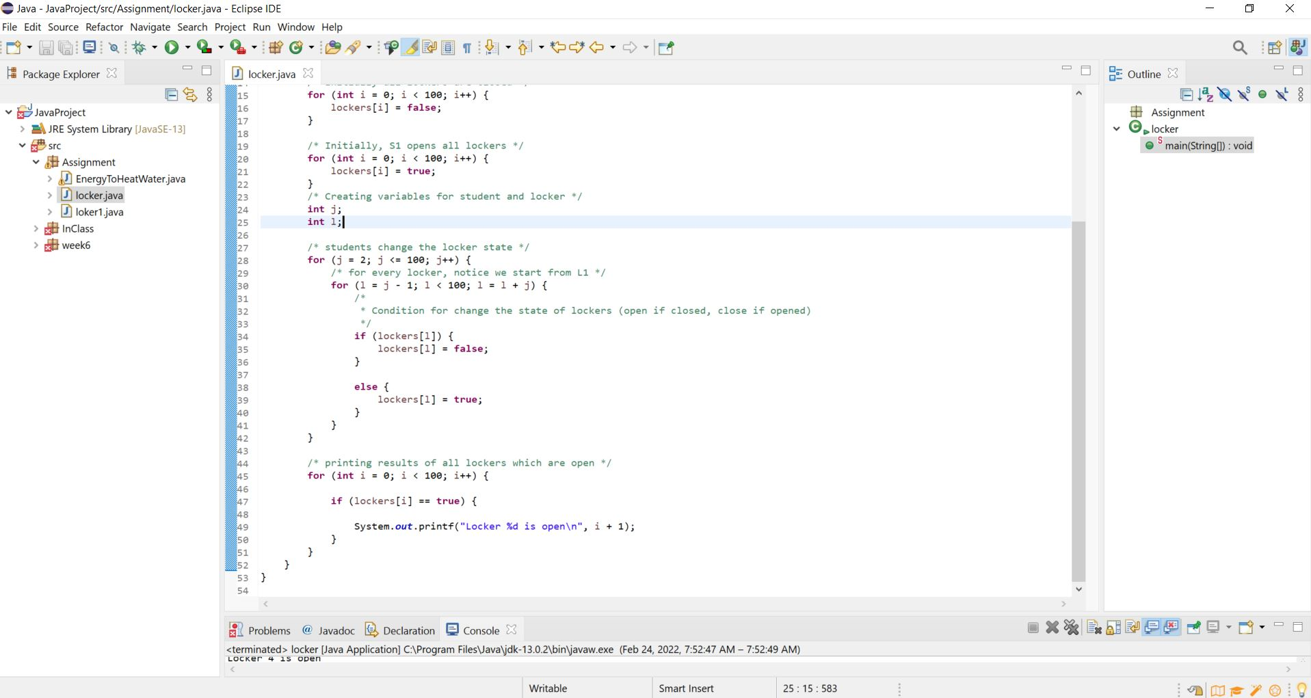

**Code part 2**

**Testing:**

1. For testing we have to run code and note the results.
2. Then we have to actually take piece of paper and calculate corresponding the results.
3. The results we have got manually should be matched with the code output.

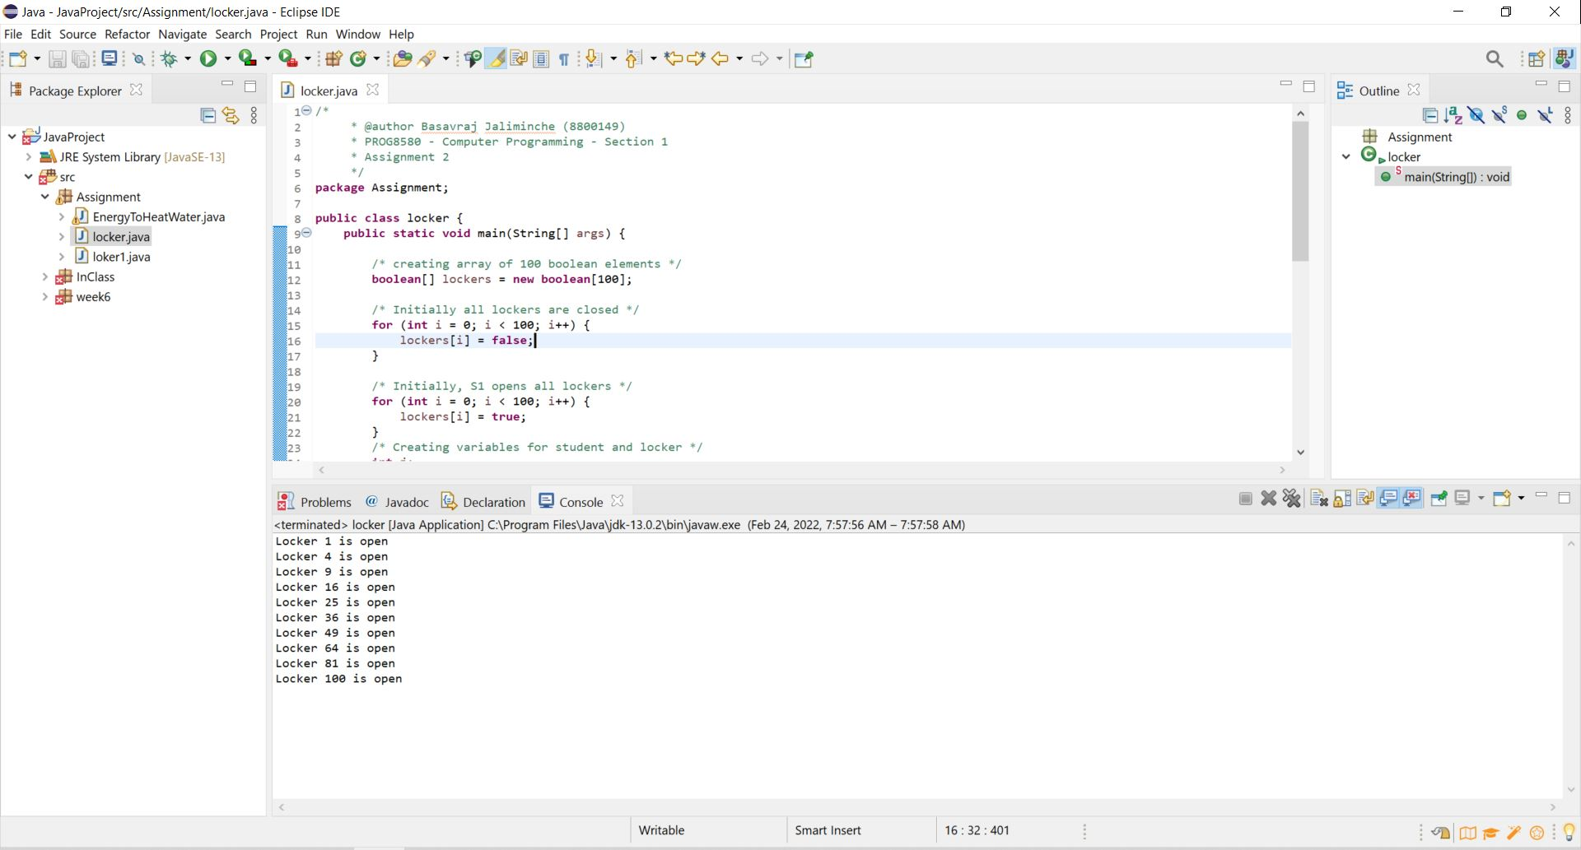

**Test Results**